
THE GARDEN CLUB OF NEW MILFORD
POPPY PROJECT

Knit Patterns

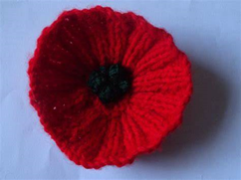
PATTERN #1
Button (Optional)
Red yarn Black yarn (optional) Green yarn (optional)
Cast On: 50 sts.
1st Row: (Right Side) Knit into back of each stitch.
2nd Row: (Wrong Side) * P2, K1, P2 *, rep from * to *, to end.
3rd Row: (Right Side) *K2, P1, K2 *, rep from * to *, to end.
Repeat last two rows 2 more times, and the 2nd Row once. (8 rows in all)
(optional: - Change to black)
9th Row: *K2 tog., repeat form * to the end.... 25 sts.
10th Row: *k2 tog., repeat from * to last st., K1.... 13 sts.
(optional: last row change to green)
11th Row: *k2 tog., * repeat from * to last st., K1.... 7 sts.
Cut a tail and thread through 7 sts., and pull tight. Then sew up the Poppy.
Optional: - sew on button.

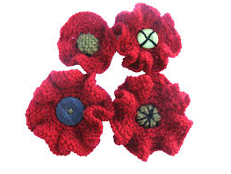
PATTERN #2
Size 4 knitting needles (we want the finished flower to be quite tight). Color A 1 ball red yarn (one ball will make many poppies)
Col B Scrap of green yarn Col C Scrap of black yarn
Body of Poppy
Using Col A cast on 120 stitches
Rows 1-4 Knit
Row 5 Knit 3 together across the row (40 stitches)
Rows 6-9 Knit
Row 10 Knit 2 tog across the row (20 stitches)
Rows 11-14 Knit
Row 15 Knit 2 together across the row (10 stitches)

Cut yarn leaving a tail of about 8”. Thread tail through yarn needle and slip all the remaining live stitches onto the yarn tail and pull tight. `Pull around into a circle and then mattress stitch seam for an invisible seam. Sew in ends.

Center of Poppy
Using Col B Cast on 8 stitches and knit a square (approx 8-10 rows) of stockinette stitch. Cut yarn leaving a tail and thread through stitches as previously. The purl side is the right side. Run a line of running stitch around the outside of the knitted square and ease enough to pull the edges of the square into a round and tuck under. Stitch tucked side down to center of poppy and overstitch with black yarn as shown in the photograph above.

Alternatively .... use a black or green button with 4 holes and sew it to the center of poppy.
NB : I have sewn a running stitch around the edge of the knitted circles and each of the buttons to gather in the center of the poppy to give it some depth. This is not absolutely necessary.

PATTERN #3
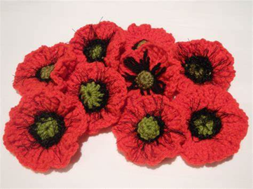
Black and red yarn., Decorative button if required
Cast on 52 stitches
Row 1-6 : rows in 2 x 2 rib
Row 7-9 : knit 2 tog across row. Where there is an odd number of stitches knit the last stitch.
Cut yarn and thread through the remaining stitches and pull them up to form a poppy. Stitch side seam and attach center.
NB last three rows can be done in black yarn to form the center, but a knitted center or button works equally well.

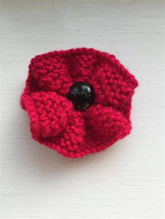
PATTERN #4
Black and red yarn

"PSSO" -- to pass slipped stitch over.
- Slip 1 stitch knit wise from the LH needle to the RH needle.
- Knit the next stitch on the LH needle.
- Insert the tip of the LH needle into the slipped stitch and bring it over the knitted stitch and off the needle as if you were binding off.

Cast on 70 stitches

Row 1-6 Knit *you can knit 8 rows if your tension is tight, or you are using a smaller ply yarn)
Row 7: *slip 1, knit 2 tog, psso Repeat from *across row. If there is an odd stitch remaining knit
Row 8-9: Knit 2 tog across row.
Cut yarn and thread through the remaining stitches and pull up to form a poppy. Stitch side seam and attach center. Last three rows can be done in black yarn to form the center, but a button works equally well.

GARDENCLUBOFNEWMILFORD.COM
NMGARDENCLUB@GMAIL.COM

